IKEA Dark Crab Sofa

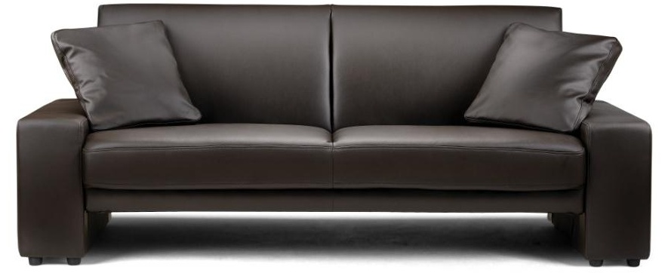

|  |
| --- |
| **DESCRIPTION** |
| The Crab Sofa produced by IKEA designs presents a sleek, low profile design that is both functional and comfortable. The extra-wide and deep relaxed form on top and extra long legs on bottom provides stability for the sofa. Short four multi legs on each side sofa prevent the wood under from bending and breaking. The thick heavy layer of cushion for the sofa is very good in making things to stay put. Perfect for relaxation. |

|  |  |  |
| --- | --- | --- |
| **Price** | **4000$** | |
| **Dimensions** | **H** x **W** x **L** | **28in x 32in x 66in** |
| **Features** | **Comfortable for two people sleek and presentable design enables the sofa to hold weight of four to six people. Completely build for high pressure.** | |
| **Finished** | **Black Platinum Strength** | |
| **Available in** | **Black and Red** | |